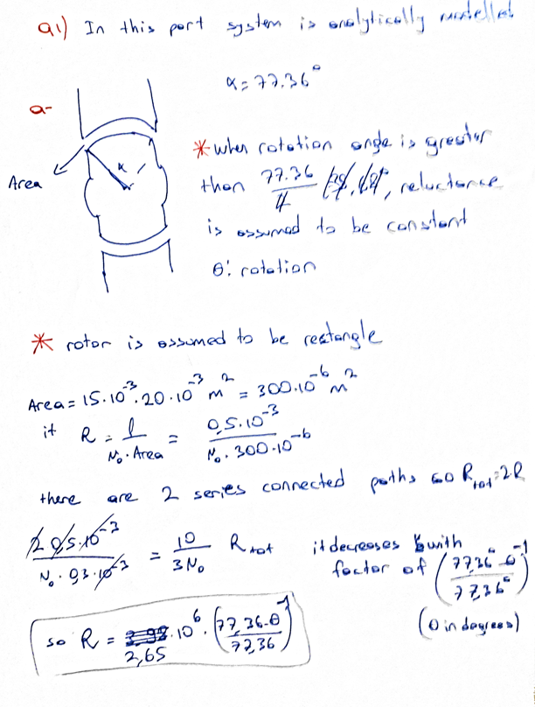

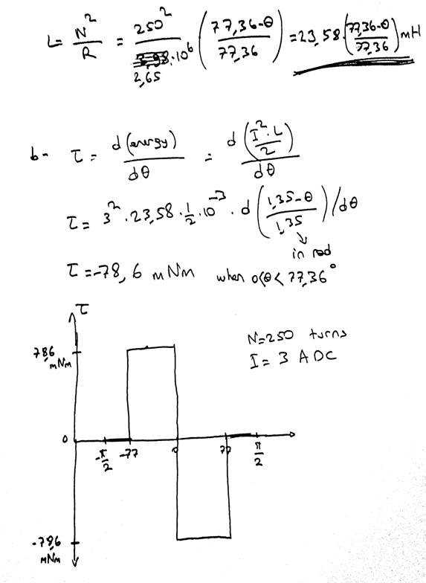

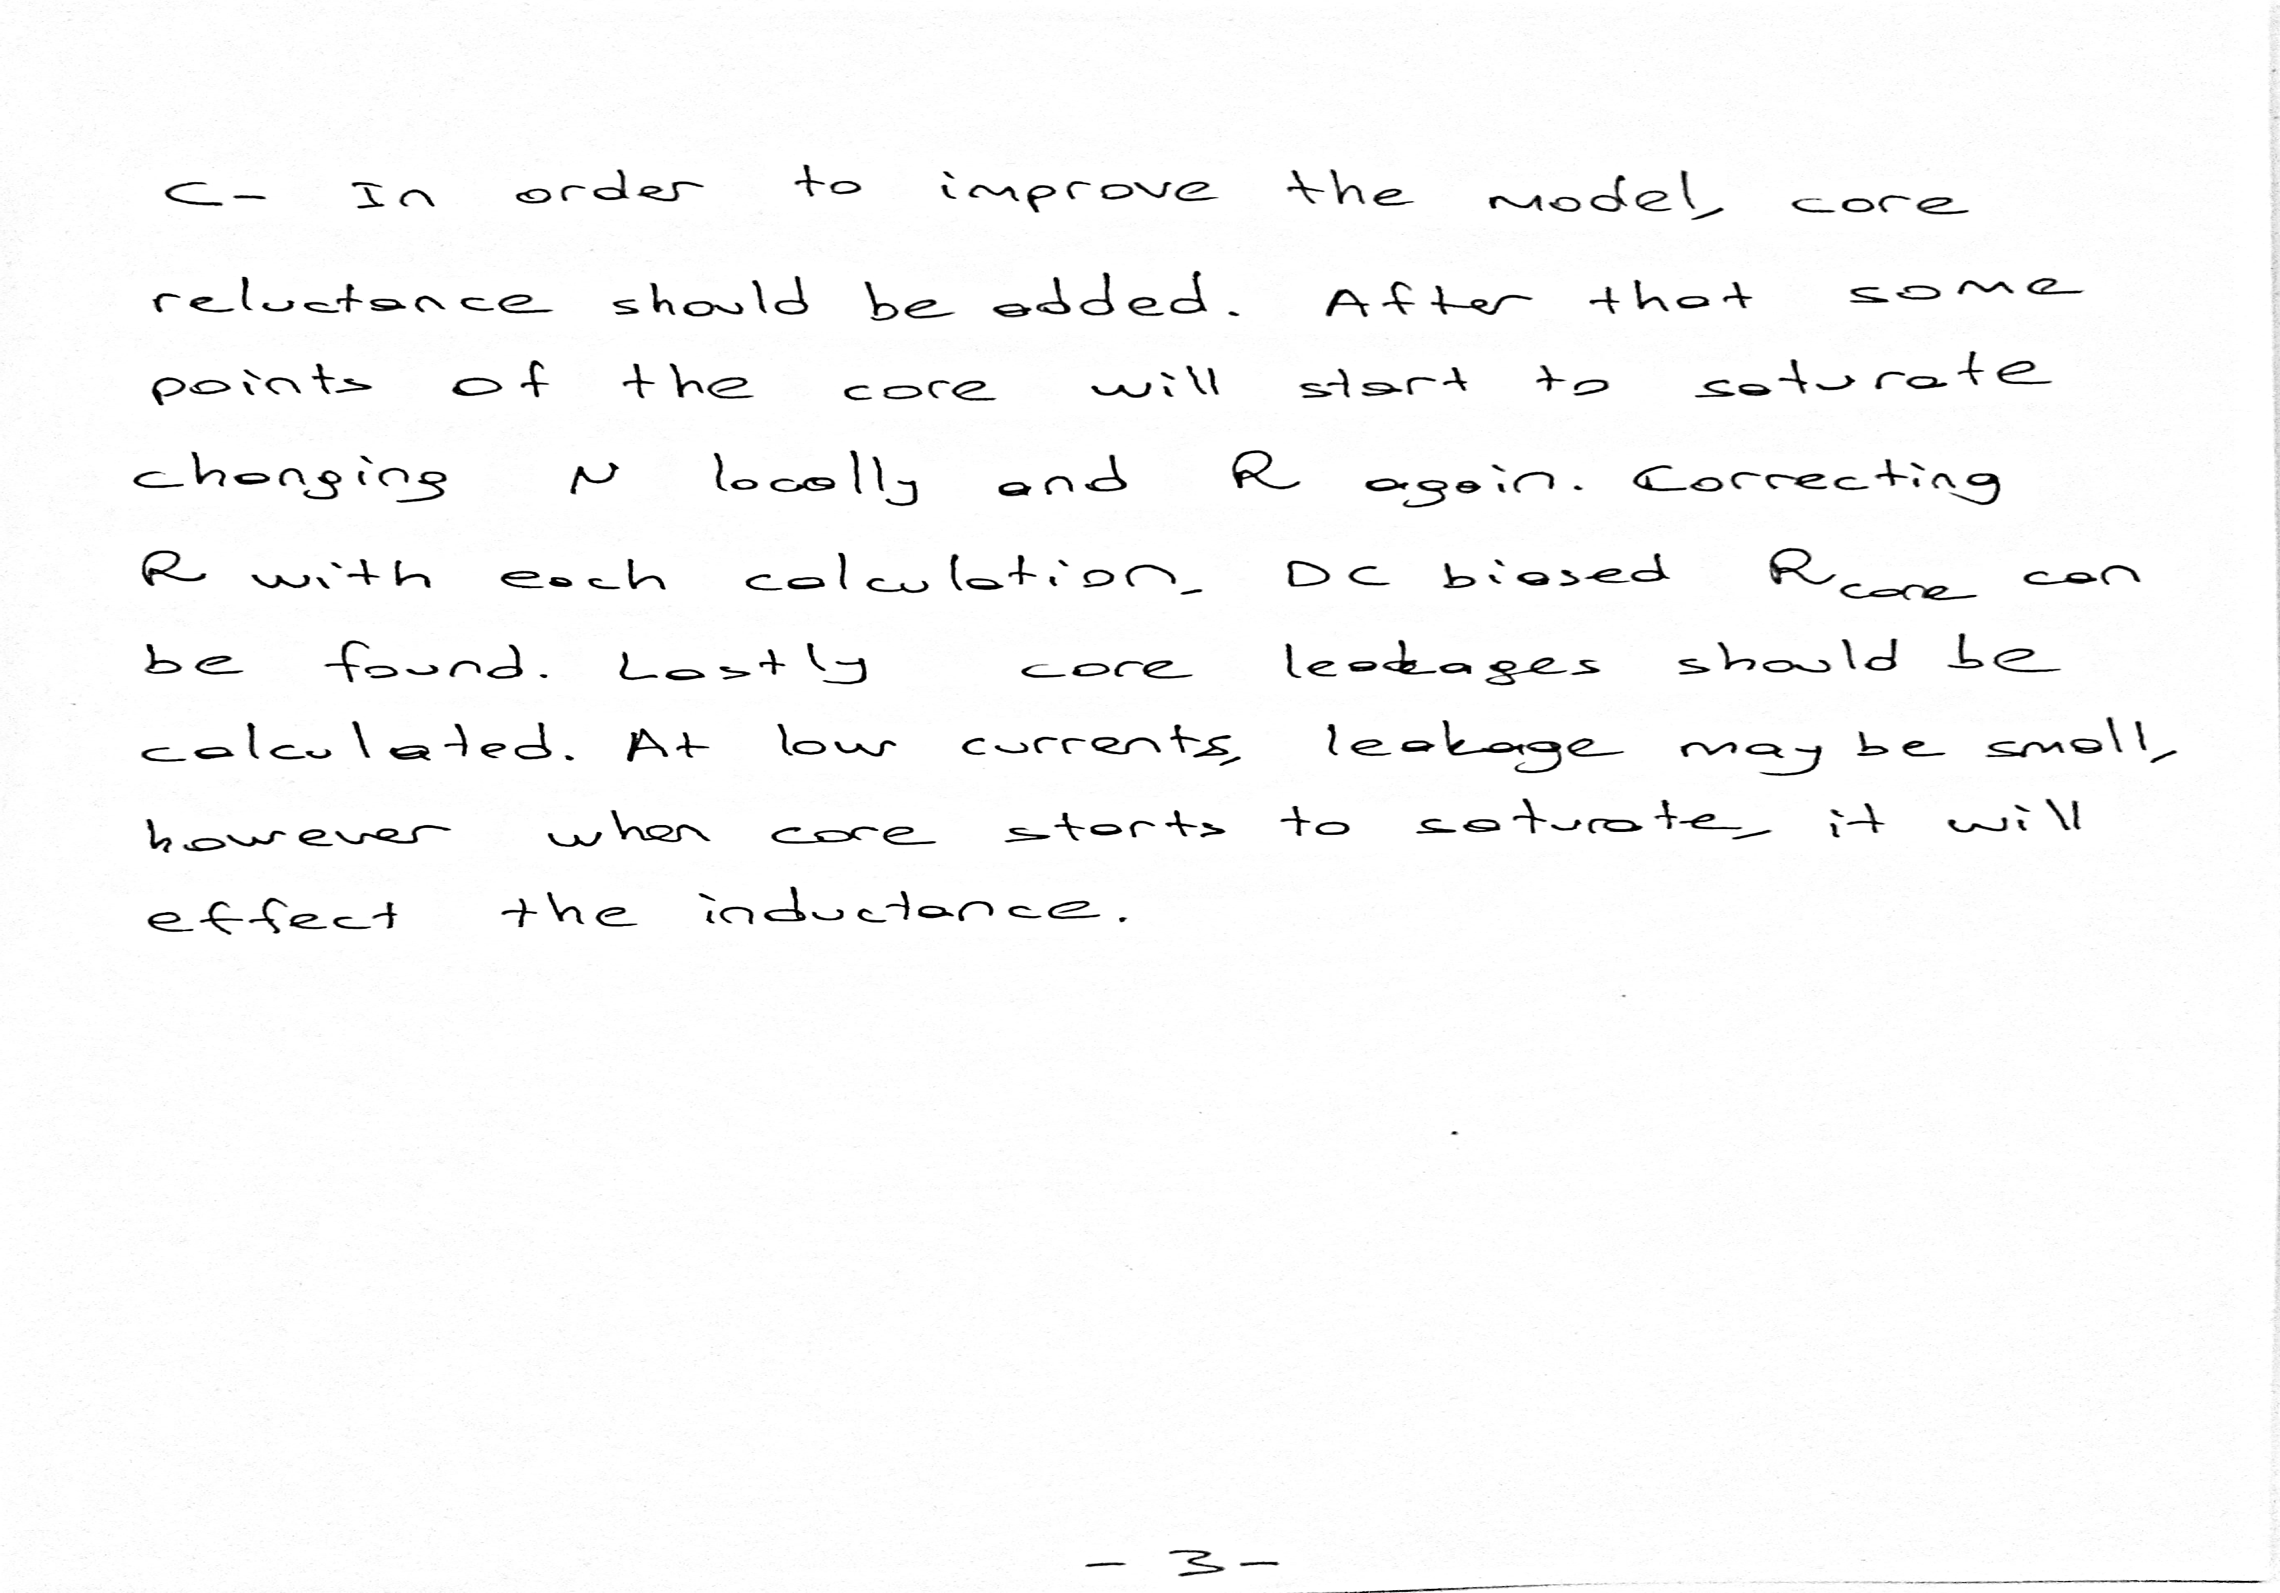

## Q2)

In this part, model is simulated by using a 2D FEA software. Firstly, steels are assumed ideal in terms of magnetic properties. In other words, magnetic permeability is constant. In the simulation it is taken as 4000 u0. 2D model is shown in figure1.

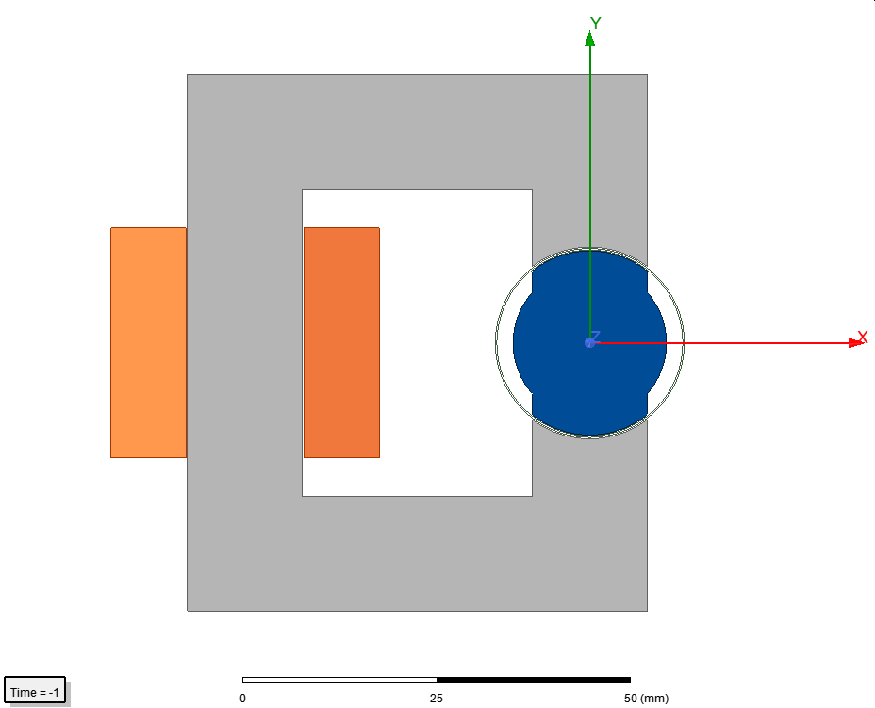

Figure 1 2D model

Copper regions are approximated as solid parts. Number of turns is 250 and current is 3 A.

Flux density vectors are given in figures 2,3 and 4 for angles 0, 45 and 90 degrees.

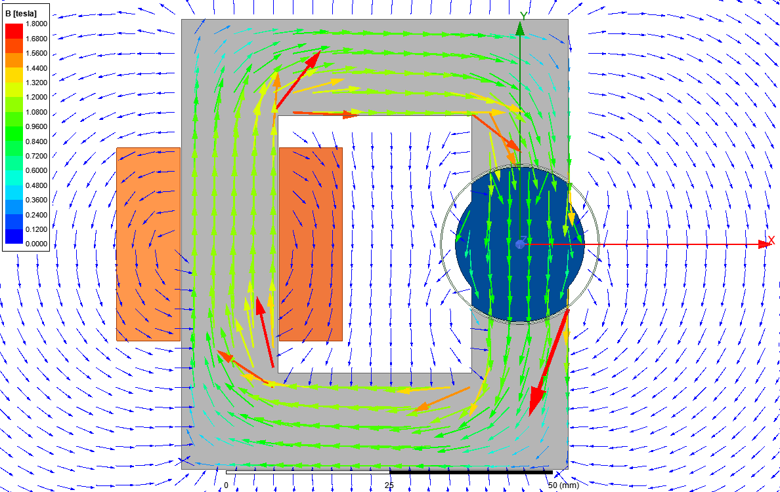

Figure 2

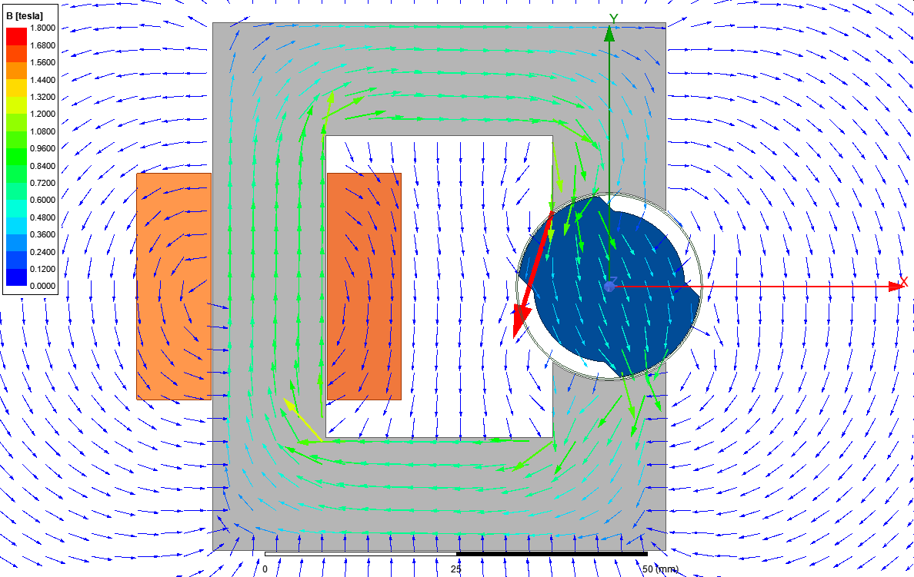

Figure 3

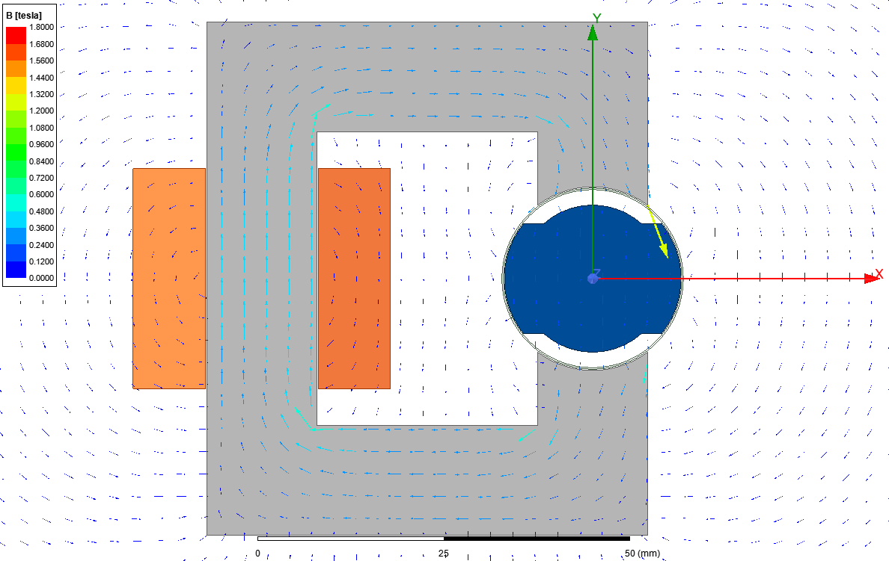

Figure 4

Inductance vs angle table is given in table1.

Table 1



Inductance vs angle graph is given in figure 5.

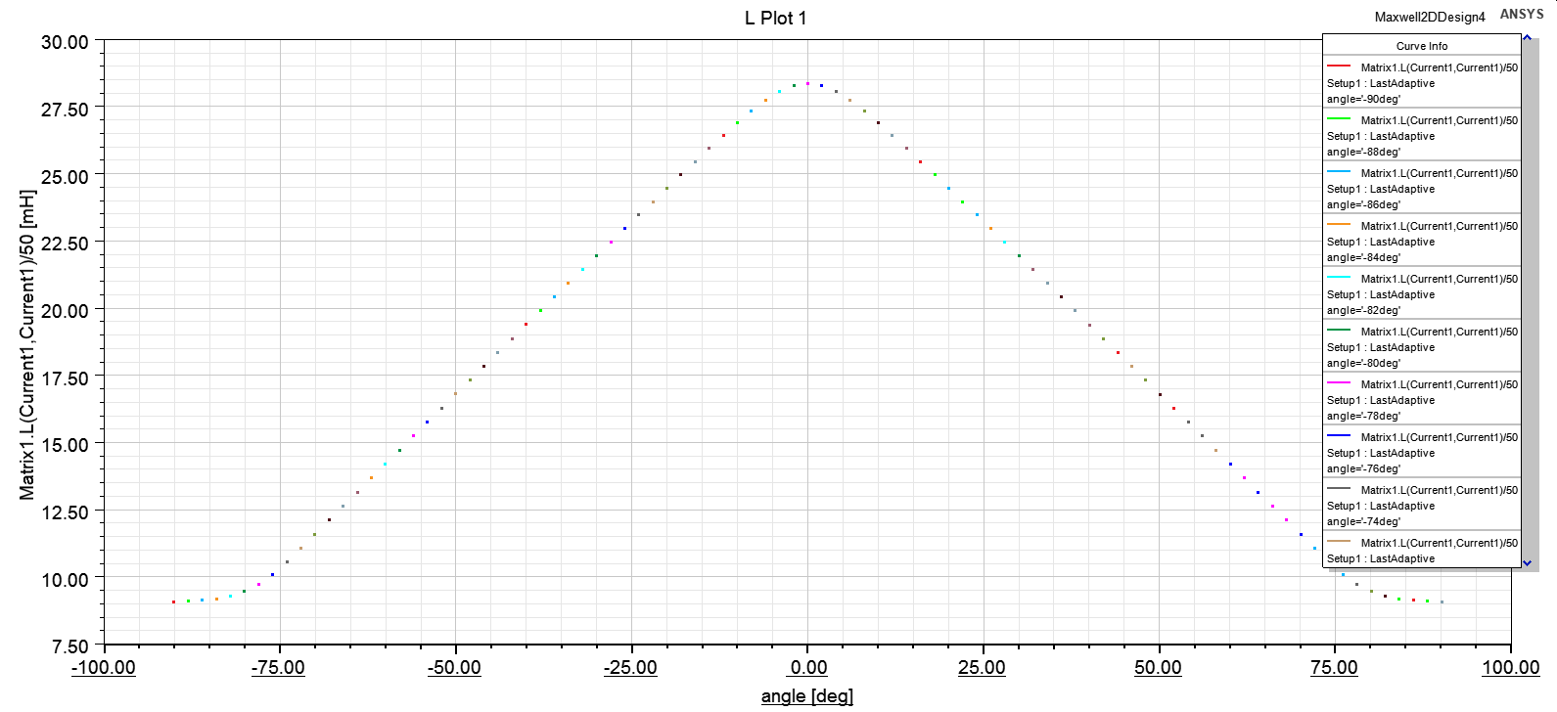

Figure 5

Total energy vs angle is given in table 2.

Table 2 energy vs angle

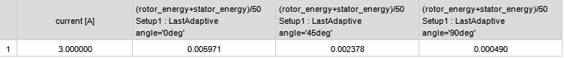

Total coenergy vs angle is given in table 3

Table 3 coenergy vs angle



It can be seen that energy and coenergy is equal to each other. Since linear a material is used, this is expected.

Torque vs angle is given in figure 6

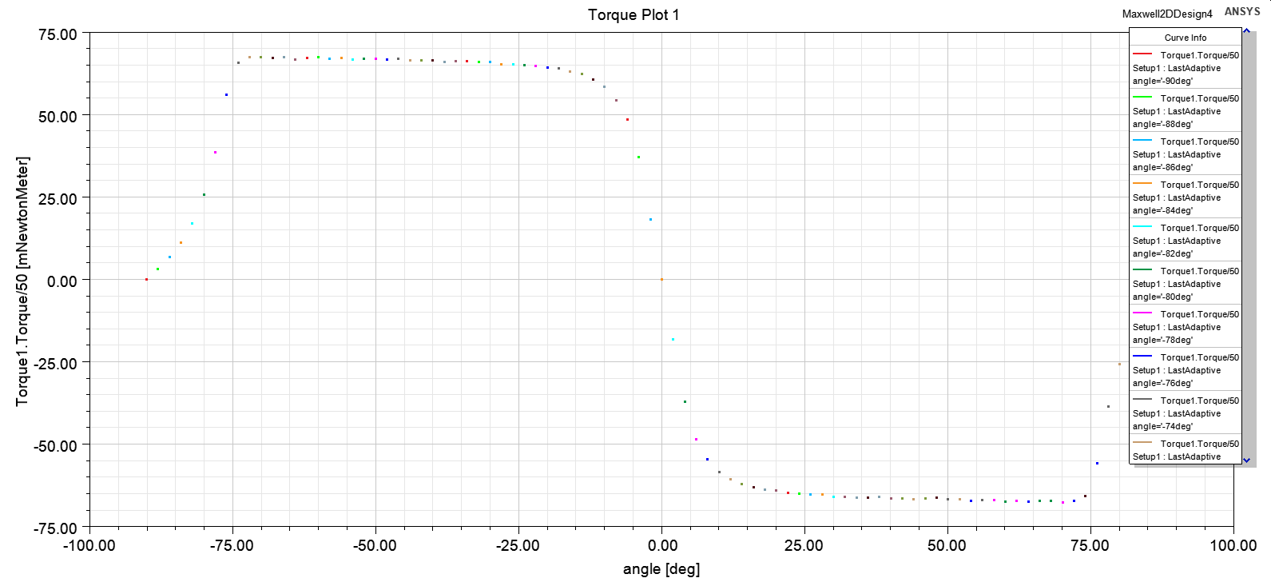

Figure 6

## Q2)

In this part material is changed to a nonlinear steel.

Flux density vectors are given in figures 7,8 and 9 for angles 0, 45 and 90 degrees.

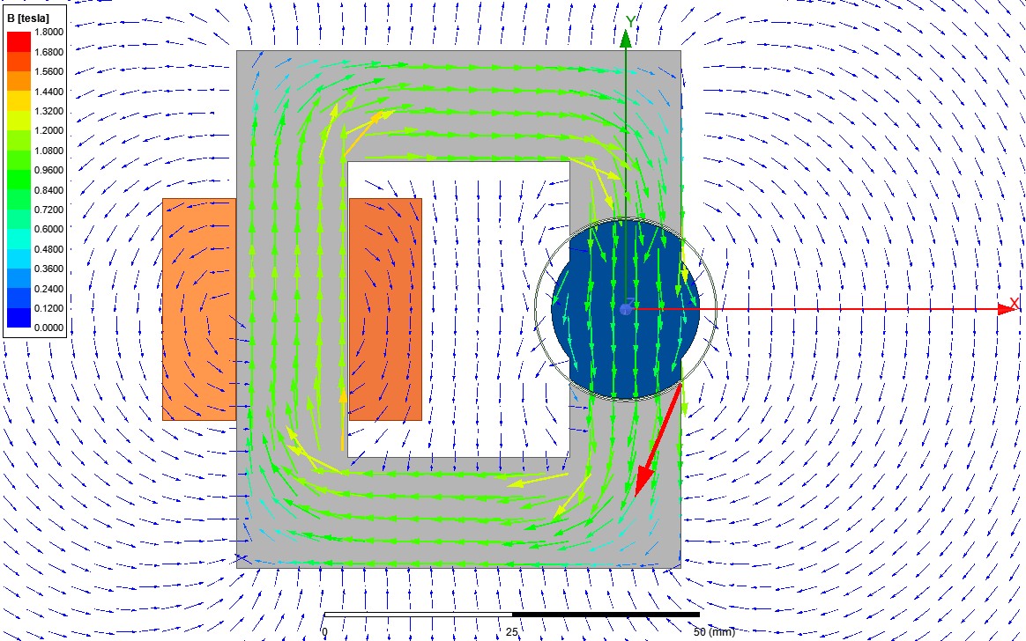

Figure 7

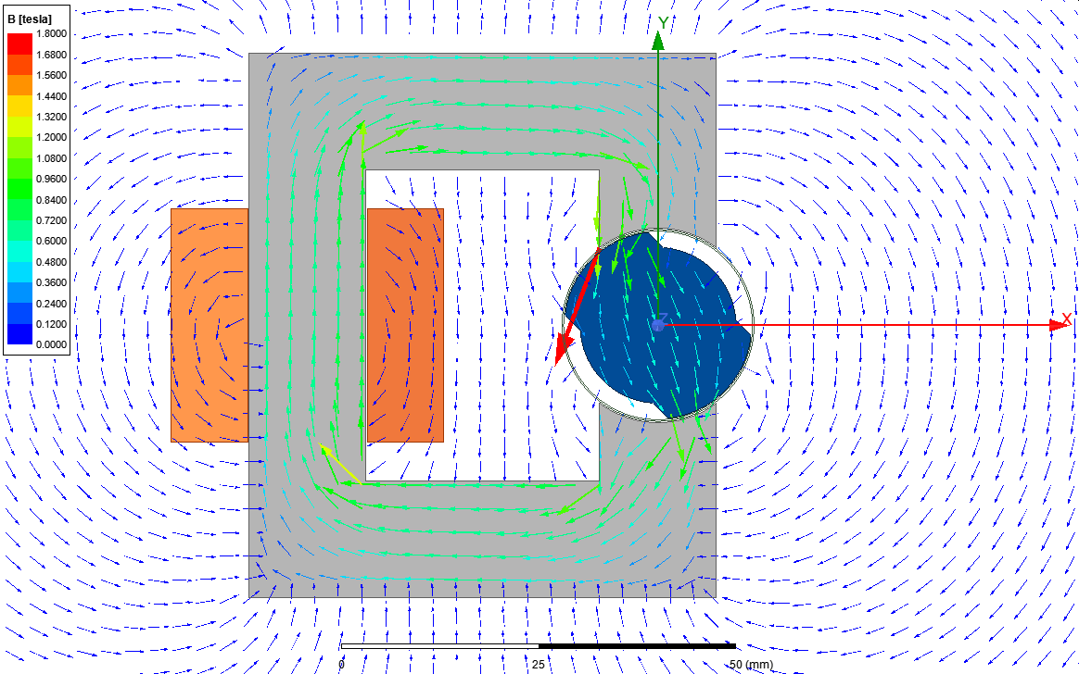

Figure 8

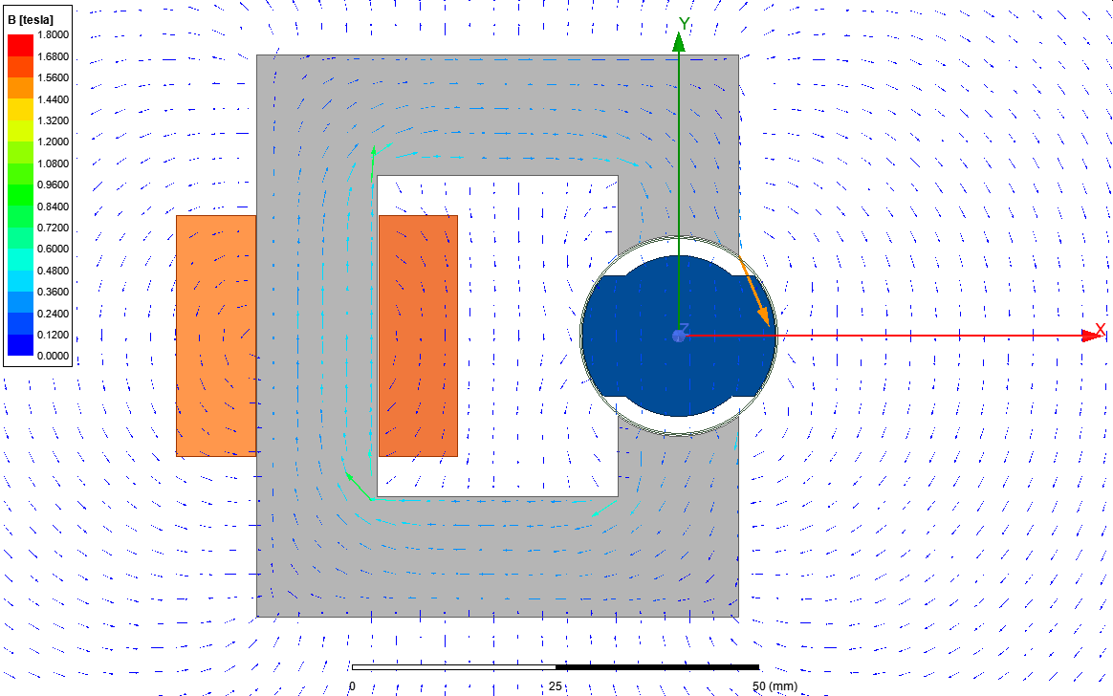

Figure 9

Inductance vs angle table is given in table4.

Table 4



Inductance vs angle graph is given in figure 10.

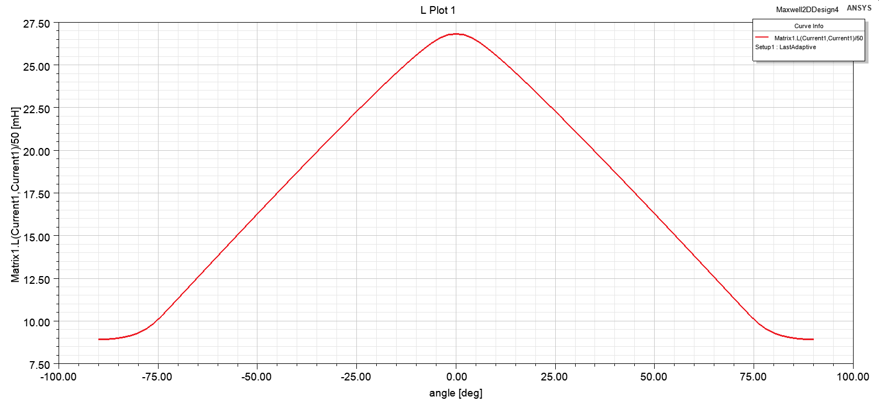

Figure 10

Total energy vs angle is given in table 5.

Table 5

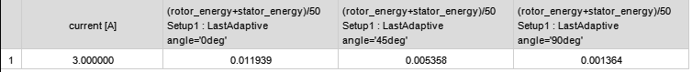

Total coenergy vs angle is given in table 6.

Table 6



Torque vs angle is given in figure 11.

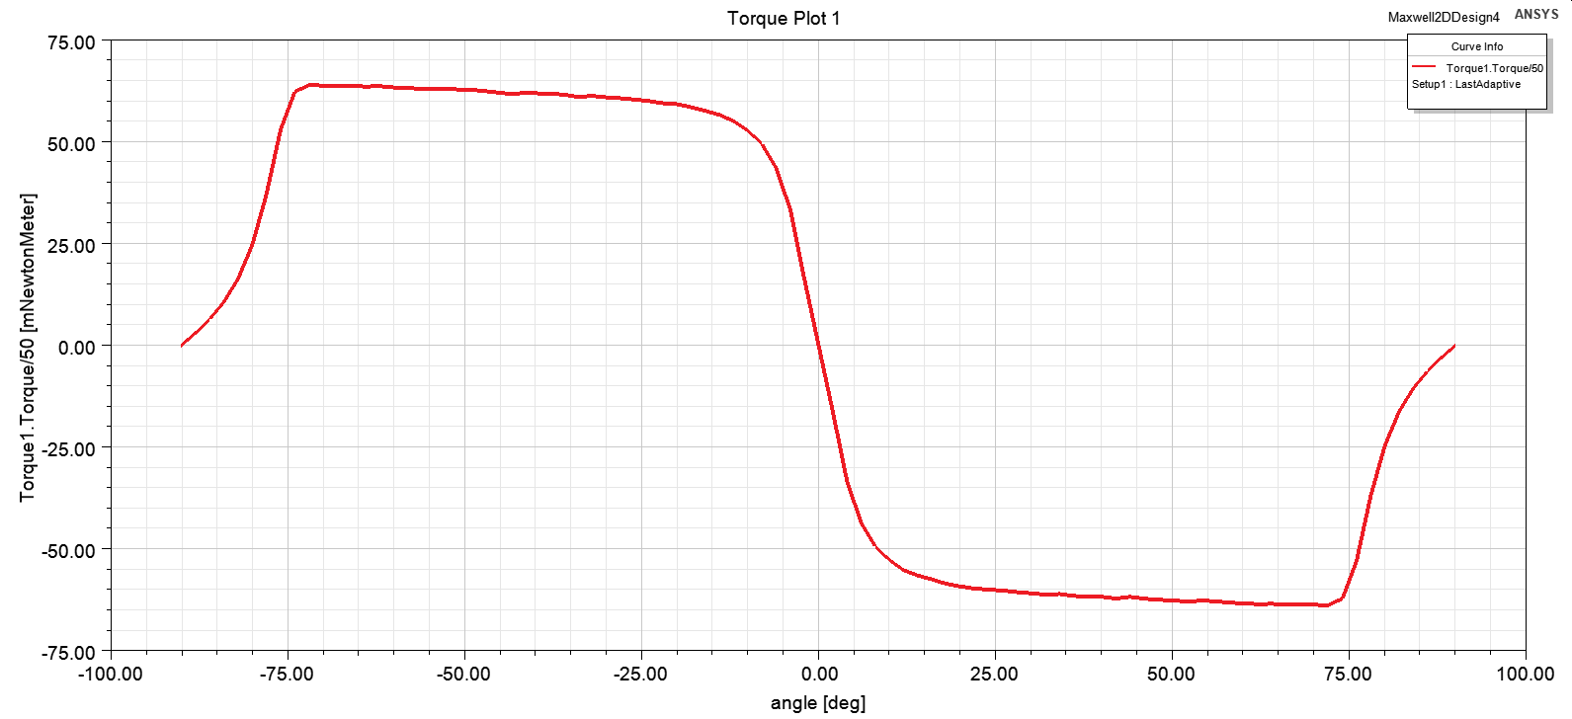

Figure 11

## Q4)

In this part we are required to propose a method to run the machine continuously. The problem with DC excitation was the average torque. There were some points that torque is positive. However just after that, torque becomes negative so net torque is always zero.

Torque with transient motion is shown in figure 12.

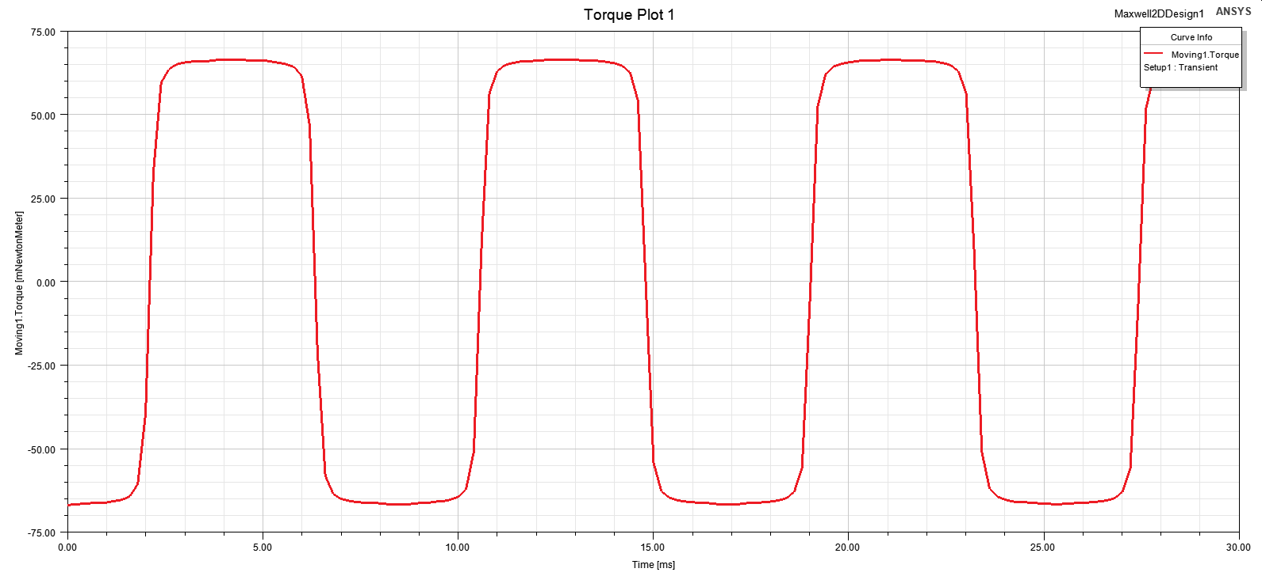

Figure 12

In order to make average torque greater than zero, we have to eliminate the regions with negative torque. To do that, we can stop the current flow for negative torque angles and start it for positive torque angles. Resultant would be a square wave with increasing frequency with respect to rotation speed.

## Q4)

Added in .avi format.